**A Citizens’ Guide to the Federal Budget for 2023/24**

Ministry of Finance

*Fulfill Your Obligation and Ask for Your Rights!*

MINISTRY OF FINANCE-ETHIOPIA 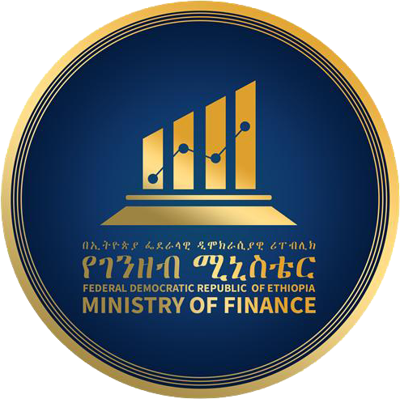

**A Citizens’ Guide to the Federal Budget for 2023/24**

[Type the company address]

***What is inside?***

***Forwards……………………………………………………………………………………………………………i***

***Acknowledgements………………………………………………………………………………………iii***

***Abbreviations…………………………………………………………………………………………………iv***

***Introduction………………………………………………………………………………………………………1***

***The Budget………………………………………………………………………………………………………2***

***Macroeconomic Update………………………………………………………………………………5***

***Where does the Government’s Money come from? …………………………5***

***Priorities in Allocations and Spending……………………………………………………7***

***Budget terminology (glossary) …………………………………………………………………9***

***Table of Contents***

*MESSAGE FROM THE MINISTER OF FINANCE...................................................ii*

1. *Introduction................................................................................................1*
2. *What is a Budget?.......................................................................................1*
3. *Objective of the EFY 2016 (2023/24) Budgt.................................................2*
4. *Macro-Economic Performances and Targets of EFY 2015 (2022/23)…….....3*
5. *EFY 2016 (2023/24) Budget.........................................................................5*
   1. *Where is the Money Coming from and How Much?...............................5*
   2. *Where does the Money Going?...............................................................7*
   3. *How Government Covers the Expenditure Obligations?........................7*
   4. *Government Expenditure Plan on Basic Activities and programs.......10*
   5. *Regional States Subsidies and SDGs Support from Central Government for EFY 2015(2022/23)......................................................................12*
6. *Budget terminology (glossary).......................................................................13*

**Message from the Minister of Finance** 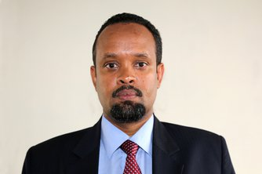

Now days, Our economy has been facing significant macro-economic imbalances that are seen in the high external debt, high inflation, low foreign currency reserve, rising unemployment, low-quality social services, and basic infrastructure that fail to meet demands of the citizens’.

In order to act on these challenges, our administration introduced the Homegrown Economic Reform program with the foundational objectives of supporting sustainable economic growth, maintaining a stable macroeconomic environment by reducing debt vulnerabilities, and creating adequate and high-quality job opportunities.

Our government’s ten-year development plan also delivers a long-term vision of Ethiopia becoming a middle-income country by 2025 and an “African Beacon of Prosperity.”

The Ministry of Finance which formulates macro-economic, fiscal, and revenue policies is committed to playing its role in realizing the implementation of both the Homegrown Economic Reform program and the ten-year development plan through full engaging of citizens and openness to the public in the implementation of public budget processes. In this regard, we have been already endeavored to promote transparency and exercising accountability in all public institution through already established financial transparency and accountability tools. Through this process our citizens have been able to easily track the implementation of planned national expenditures and demand accountability for results, accordingly.

As part our transparency mechanisms, the Ministry of Finance, has published the Citizens Guide to the EFY 2016 (2023/24) National Budget, which is published for the third time. This Guide is a simplified version of the National Budget that enables the public to easily understand what is contained in the Government’s revenue and expenditure plans approved by the Parliament.

Therefore, I would like to remind and encourage all citizens to continue to engage and hold us accountable in delivering our commitments once again.

Ahmed Shide

Minister of Ministry of Finance

1. ***Introduction***

The Ethiopian government budget shows a process which government will decide on amount of tax to be collected, services to be provided, and amount debt to take on in order to accelerate economic growth and job creation opportunities, modernize infrastructure, and eradicate poverty and inequality. To realize this, the government should inform and engage citizens on these essential decisions that bring impact on their lives by producing a citizens’ guide on this Fiscal Year budget document.

Thus, the EFY 2016 citizens’ budget document summarizes the overall budget document of a fiscal year and explains basic information in a simplified form on what services the government plans to deliver, how it will be done, who will do it, and how much they will cost.

***2. What is a Budget?***

**A budget is a legal document that estimates a government expenditures and revenues for a given fiscal year.**

**The Ethiopian government budget process has four stages at all level of jurisdiction (Federal, Regional, and Woreda government) which is guided by Financial Calendar directive issued by the Ministry of Finance (MOF) to all public budgetary bodies (institutions).**

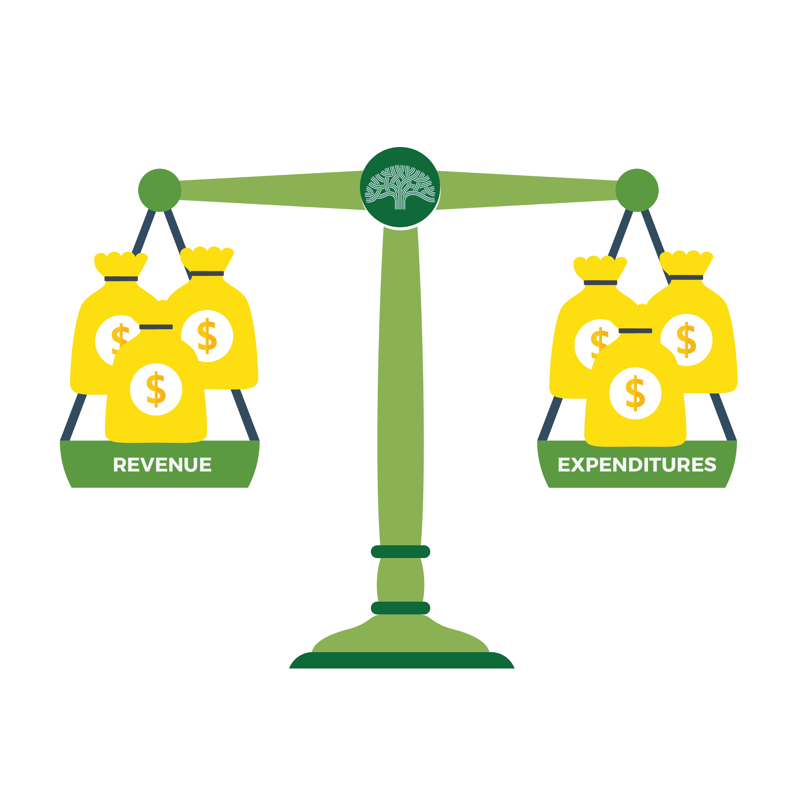

**The Four Basic Budget Processes**

**3. Objective of the EFY 2016 (2023/24) Budget**

**4. Macro-Economic Performances and Targets of EFY 2015 (2022/23)**

**Economic Growth**

The economy of the country has already set a target of 9.2 percent growth in the 2015 fiscal year. However, due to various hindrances within and outside the country, the economic growth is expected to be 7.5 percent.



**Inflation Rate**

The annual average (EFY July 2014-June 2015) country level headline inflation as computed based on 12 months moving overage method registered was 32.5 percent.

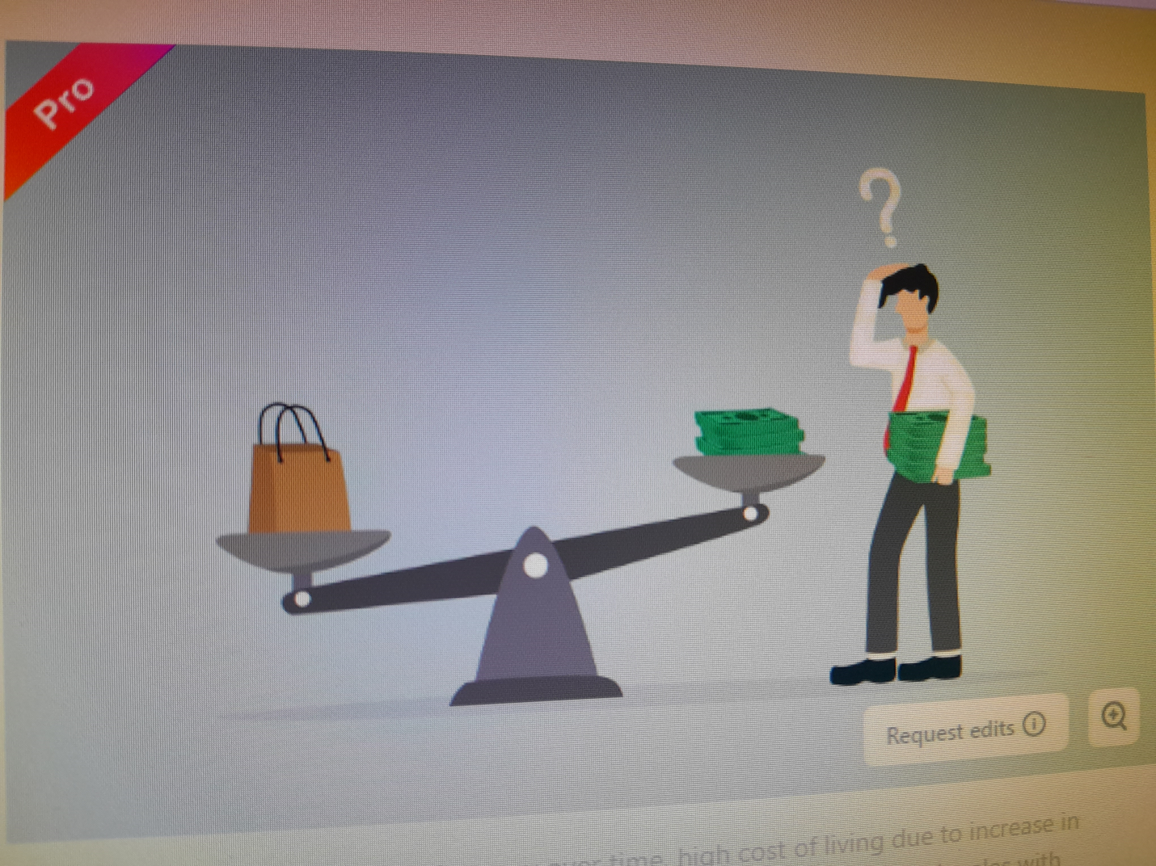

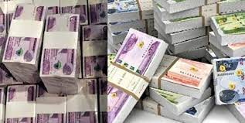

**Export of Goods**

During the EFY 2015, the performance of export of goods was 3.3 billion USD lower than the 4.1 billion USD in the preceding fiscal year.

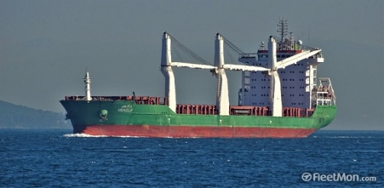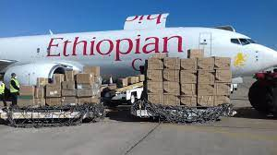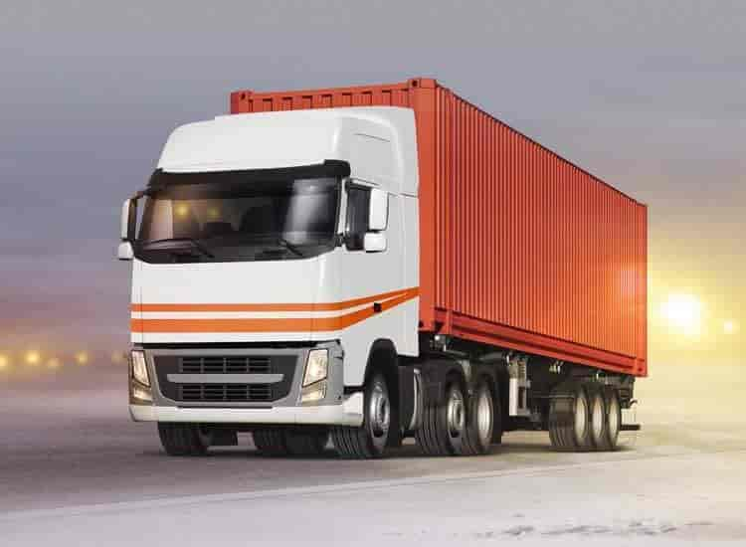

**EFY 2015 (2022/23) Fiscal Policy Performance**

1. **Revenue Collection Performance**

|  |  |  |  |
| --- | --- | --- | --- |
| Revenue sources | EFY 2015 plan | EFY 2015 Performance | Percentage |
| Tax Revenue | **124,775.1** | **116,252.81** | **93.2** |
| Domestic Non-Tax revenues | **103,363.9** | **88,532.1** | **85.7** |
| Foreign Trade Taxes and Duties | **172,104.9** | **168,552.6** | **97.9** |
| Non-Tax Incomes | **38,607.36** | **31,467.3** | **81.5** |
| Direct Budget Support | **7,659.3** | **2,426.1** | **31.7** |
| Total | **446,510.6** | **407,230.9** | **91.2** |

1. **Expenditures Performance**

|  |  |  |  |
| --- | --- | --- | --- |
| Expenditure Type | **EFY 2015 Plan** | **EFY 2015 Performance** | **Percentage** |
| Recurrent Expenditure | 267,659.0 | 268,681.3 | 100.4 |
| Capital Expenditure | 187,944.5 | 155,000.2 | 82.5 |
| Regions Subsidy | 205,041.0 | 203,219.0 | 99.1 |
| Regions SDGs Support | 14,000.0 | 12,753.3 | 91.1 |
| Total | 674,644.5 | 639,653.8 | 94.8 |
| Debt Services | | | |
| Total Deficit | 228,133.9 | (232,422.9) | 101.9 |
| Debt Coverage | 228,133.9 | 232,422.9 | 101.9 |

**5. EFY 2016 (2023/24) Budget**

**5.1. Where is the Money Coming from and How Much?**

**Key Tax Policy Reforms to Reinforce Revenue Mobilization**

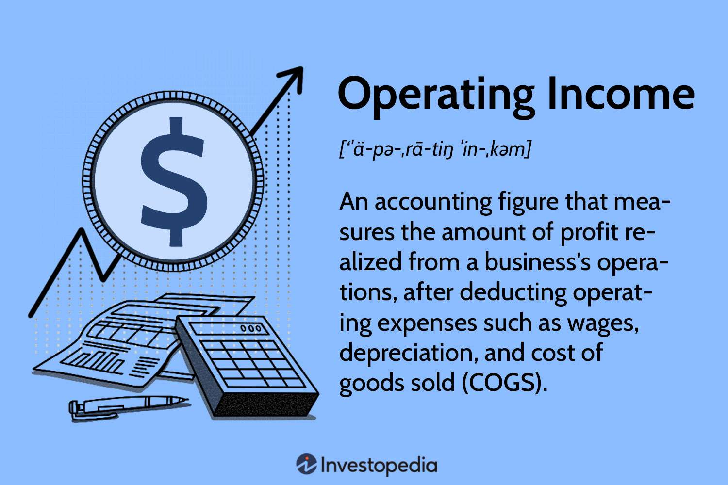

* **Value Added Tax (VAT) reforms**:- Bringing into tax system those commodities which must be taxable and other new goods and services. This will bring 1% increase of income as per GDT.
* **Excise tax proclamation** levied on luxuries goods and health treating commodities which will bring additional income of 10 billion birr.
* **Excise Stamp, and Track and Trace System** collecting additional income from excised commodities which will increase the income of excise tax by 30 billion birr
* **Tax from Social Security development:-** levied on all imported commodities which will expected increase the tax income
* **Property Tax law:-** new tax law that will be implemented and the income collected from this will be consumed by regions/city administrations.
* **Non-tax income assumptions:-** By reforming the tax laws 93.1 billion birr additional revenue has estimated.
* **Tax Administration Reforms:-** Government commitment in reforming tax collection institutions by conducting in-depth assessment of capacity gabs and implementation difficulty.

# 5.2. Where does the Money Going?

**5.3. How Government Covers the Expenditure Obligations?**

* **The Budget Deficit of the EFY 2016 (2023/24) is Birr 281.05 Billion and this has a net share of 2.1% of GDP.**
* **The deficit (gap) will be covered from domestic loan (Birr 242.04 Billion), project loan (Birr 31.57 Billion) and protecting basic services loan (Birr 7.44 Billion).**

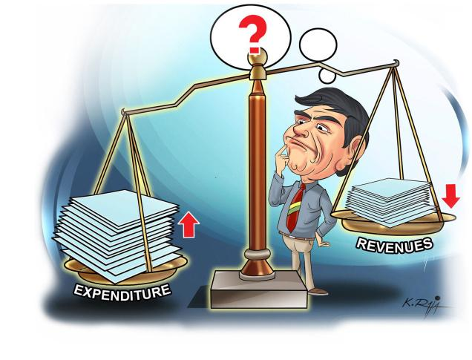

**Total Income Birr 520.60** **Billion**

**Budget Deficit**

**Birr 281.05 Billion**

**Total Expenditure Birr 801.65 Billion**

**Recurrent Expenditures**

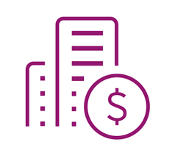

**The recurrent budget allocation is mainly to prioritize:**

* **Debt service**
* **National security protection**
* **Support for conflicts and drought affected citizens and**
* **Subsidy for purchase of fertilizer**
* **Also considers financing of main activities to achieve intended outcomes in accordance with program budgeting arrangement.**

**Recurrent Expenditures (In Billion Birr)**

|  |  |  |  |  |
| --- | --- | --- | --- | --- |
| **Services** | **EFY 2015 (2022/23) Budget** | **EFY 2016 (2023/24) Budget** | | **Difference**  **(Between EFY 2015 & 2016)** |
| **Amount** | **Percentage (%) Share** |
| **Administrative and General Services** | **111.69** | **80.61** | **21.78** | **-31.08** |
| **Economic** | **7.00** | **6.90** | **1.86** | **-0.10** |
| **Social** | **53.76** | **54.24** | **14.65** | **0.48** |
| **Budget support** | **22.63** | **21.86** | **5.91** | **-3.40** |
| **Debt Services** | **125.96** | **159.20** | **43.01** | **26.39** |
| **Contingency** | **24.09** | **47.33** | **12.79** | **96.47** |
| **Total** | **345.12** | **370.14** | **100.00** | **7.25** |

**Capital Expenditure**

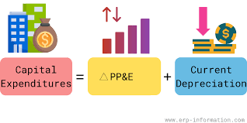

**Capital budget allocation prioritizes:-**

* Accomplishing on-going and new projects that ensures sustainable development
* Rehabilitation of damaged infrastructures and services due to internal conflicts
* Industrial development and export expansion
* Agricultural productivity
* Irrigation system development and
* Job creation goals

**Capital Expenditures (In Billion Birr)**

|  |  |  |  |  |
| --- | --- | --- | --- | --- |
| **Services** | **EFY 2015 (2022/23) Budget** | **EFY 2016 (2023/24) Budget** | | **Difference**  **(Between EFY 2015 & 2016)** |
| **Amount** | **Percentage (%) Share** |
| **Administrative and General Services** | 29.65 | 31.41 | 15.44 | 1.76 |
| **Economic** | 133.26 | 129.29 | 63.55 | -3.97 |
| **Social** | 48.69 | 37.24 | 18.31 | -11.45 |
| **Others** | 6.51 | 5.50 | 2.70 | -1.01 |
| **Total** | **218.11** | **203.44** | **100.00** | **-14.67** |

**5.4. Government Expenditure Plan on Basic Activities and Programs**

1. **Improving Road Infrastructure**



* **Building new main and feeder road infrastructure and**
* **Repairing older roads**

**Total 67.6 billion birr**

1. **Education Sector Development**

**Including**

* **higher education renovation,**
* **technical and vocational education, and**
* **General education quality improvement.**

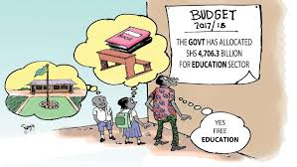

**Total 660.6 Million Birr**

1. **Irrigation System Development**

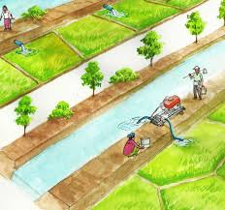

* **New major irrigation system construction and renewal works improvements**
* **Low land livelihood improvement through technological adoption and**
* **Small scale irrigation development through regions by Sustainable development goals**

**Total 16.2 billion birr**

1. **Health Sector Development**

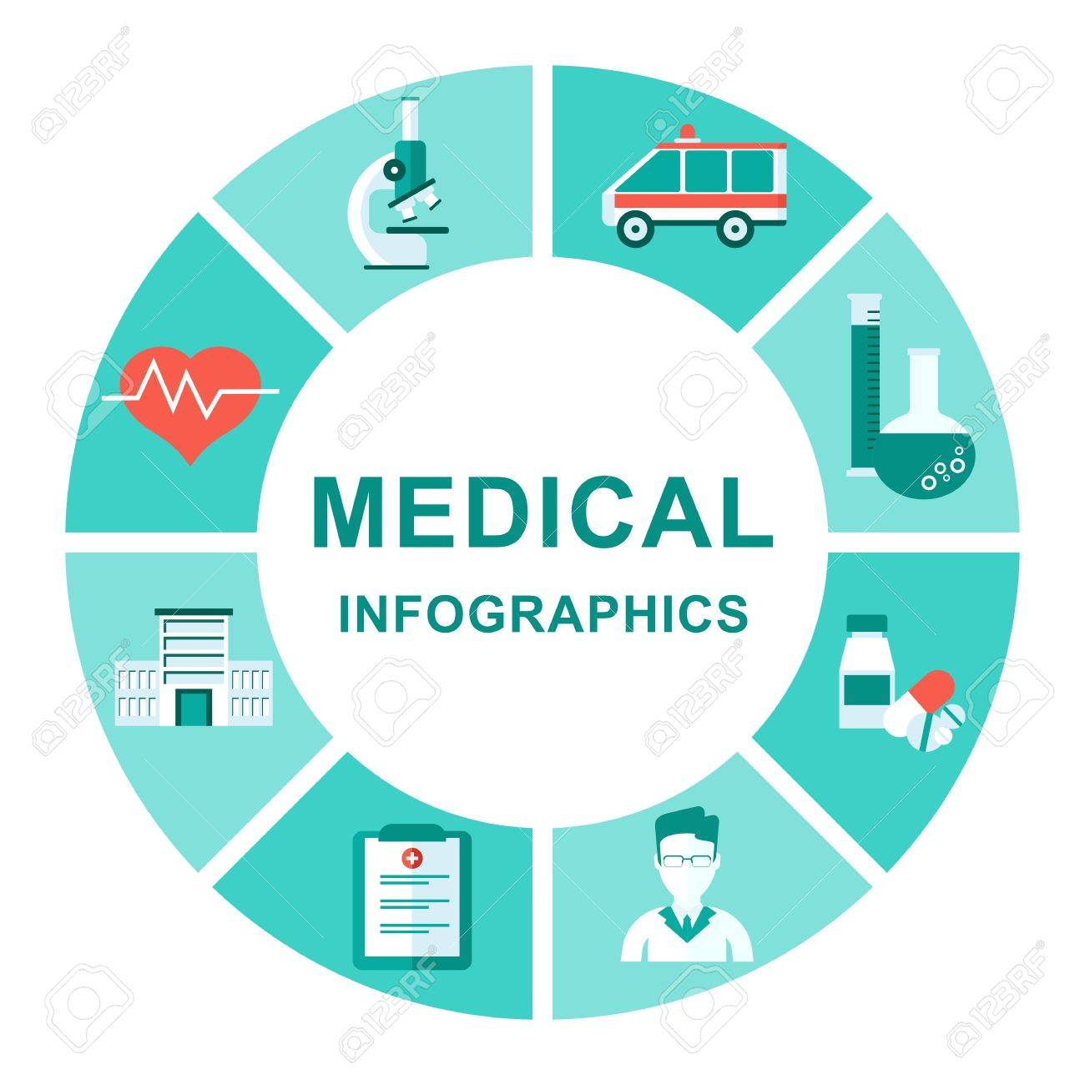

**Over all 16.8 billion birr allocated to health sector**

1. Productive Safety net Program-PSNP ne

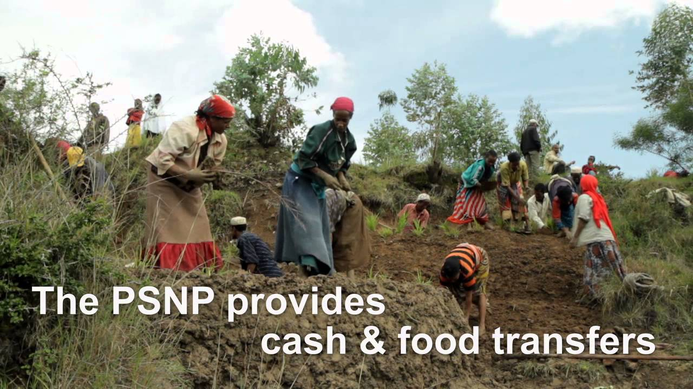

**Including**

* Productive Safety net program
* Urban Productive Safety net and
* Job creation

**Total 22.4 billion birr**

1. **Supply and Securing of Clean and Sufficient Drinking Water**

* **To secure save and clean drinking water**

**Total 8.23 billion birr allocated**

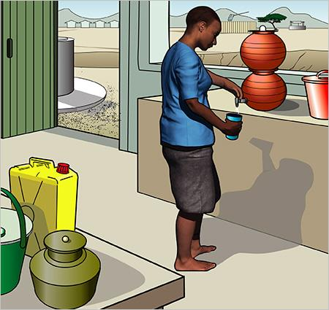

**5.5. Regional States Subsidies and SDGs Support from Central Government for EFY 2015(2022/23) (In birr)**

|  |  |  |  |  |
| --- | --- | --- | --- | --- |
| **Regional States** | **EFY 2015**  **(2022/23)** | **EFY 2016**  **(2023/24)** | **Difference** | **Support for MDGs** |
| Tigray | 12,427,896,330 | 12,591,813,948 | 163,917,618 | 844,200,000 |
| Afar | 6,224,253,220 | 6,306,347,948 | 82,094,728 | 422,800,000 |
| Amhara | 44,517,837,600 | 45,105,005,187 | 587,167,587 | 3,024,000,000 |
| Oromia | 71,022,439,060 | 71,959,188,831 | 936,749,771 | 4,824,400,000 |
| Somalia | 20,568,889,780 | 20,840,182,952 | 271,293,172 | 1,397,200,000 |
| Benshangul Gumuz | 3,771,650,130 | 3,821,396,273 | 49,746,143 | 256,200,000 |
| SNNPs | 26,591,356,338 | 26,942,082,775 | 350,726,437 | 1,806,293,070 |
| Gambella | 2,741,144,630 | 2,777,298,930 | 36,154,300 | 186,200,000 |
| Harari | 1,566,368,360 | 1,587,027,961 | 20,659,601 | 106,400,000 |
| Addis Ababa City Administration | 3,279,614,780 | 5,254,541,684 | 1,974,926,904 | **0** |
| Dire Dawa Town Administration | 1,813,689,680 | 1,837,611,323 | 23,921,643 | 123,200,000 |
| Sidama | 8,455,173,967 | 8,566,693,402 | 111,519,435 | 574,341,600 |
| Southern West Ethiopia Peoples | 6,400,400,905 | 6,484,818,931 | 84,418,026 | 434,765,330 |
| **Total** | **209,380,714,780** | **209,380,714,780** | **4,693,295,365** | **14,000,000,000** |

# Budget terminology (glossary)

## Administrative Jurisdiction: describes the authority of the administrative courts to decide in the area of administrative law.

## Budget Call: A Circular by MOF that contains budget preparation forms, instructions and procedure for preparation and submission of detailed budget estimates.

## Budget Deficit:  The gap between expenditure and revenue for the intended Fiscal Year and expressed in terms of percentage of the Gross Domestic Product (GDP).

## Budget oversight: monitors the execution of the budget, to provide checks and balances on the enacted budget.

## Budget Request: an itemized summary of expenditure of an organization over a specified period, usually a financial year submitted to MOF.

## Budget Subsidy (Budget grant): Budget support provided to regions by Federal government.

## Capital Expenditure:  the expenditure of funds by government for an asset that is expected to provide utility for organizational service provision.

## Domestic Sources: the process through which government raise and spend its own funds from different sources within the country to provide services for its people.

## Economic Stability: the absence of excessive fluctuations in the macro economy. Or an economy with fairly constant output growth and low and stable inflation would be considered economically stable.

## External Assistance: support from external sources for budgeting to fulfill expenditure obligation by the government for a given fiscal year.

## Ethiopian Fiscal Year (EFY): a period of time used by the government for annual financial statements from July 08 to July 7 (From Hamle 01 to Sene 30 according to Ethiopian Fiscal Year).

## External Loan: loan from external sources for budgeting to fulfill expenditure obligation by the government for a given fiscal year

## Fiscal Policy: government spending and revenue to influence the economy.

## Financial Resource/Revenue: sources of finance from which government obtains the funds it needs to finance its investments, capital and recurrent activities.

## Fiscal framework: the determination of financial resources available for expenditures during the fiscal year.

## Medium Term Fiscal Framework: fiscal arrangements that allow government to extend the horizon for fiscal policy making beyond the annual budgetary calendar. Three-year spending plans of the Ethiopian governments.

## Gross Domestic Product (GDP): the monetary value of all finished goods and services made within a country during a specific period.

## Inflation Rate: the percentage change in the price index for a given period compared to that recorded in a previous period. A price index means a weighted average of the prices of a selected basket of goods and services relative to their prices in some base-year.

## Macro-Economic Fiscal Framework (MEFF): the framework provides the context under which fiscal targets are set, policy choices are determined, and realistic revenue and expenditure projections are prepared.

## Policy: a system of laws, regulatory measures, courses of action, and funding priorities concerning a given topic publicized by a governmental entity or its representatives.

## Public Entity (Public Budgetary Institutions): any entity established or controlled by the federal government, including, but not limited, institutions of higher education and related research institutions providing services to the public on behalf of the government.

## Recurrent Expenditure: expenditure on goods and services that does not result in the creation or acquisition of fixed assets, and which consists mainly of expenditure on wages, salaries and supplements, purchases of goods and services.

## Sustainable development Goals (SDGs): the blue print to achieve a better and more sustainable future for all. They address the global challenges we face, including poverty, inequality, climate change, environmental degradation, peace and justice.

For more information, please contact:

Email: [**infopr@mofed.gov.et**](mailto:infopr@mofed.gov.et)

Phone: + 251-111-552-015

Fax: + 251-111-555-189 fax

***Addis Ababa, Ethiopia***